What’s Next for Psychedelic Medicines?
After the FDA delayed the approval of MDMA-assisted therapy for PTSD, there's still a way forward for psychedelic medicines, experts said at HLTH.
By Marissa Plescia on October 30, 2024
Share
From left to right: Ruth Reader, Health and Technology Reporter, POLITICO; Kyrsten Sinema, U.S. Senator of Arizona; Shereef Elnahal M.D., M.B.A.., Under Secretary for Health, US Department of Veterans Affairs; Morgan Luttrell, Congressman, US Congress
After the Food and Drug Administration’s recent decision to delay the approval of MDMA-assisted therapy for post-traumatic stress disorder, the path forward has become less straightforward for the field of psychedelic medicines. But this isn’t the end of the road, according to a panel of experts last week at the HLTH 2024 conference in Las Vegas.
The new drug application was submitted by Lykos Therapeutics and would have been the first new treatment option for PTSD in over two decades, according to the company. The drug would have been provided with talk therapy. The FDA requested in August that the company conduct an additional Phase 3 trial to evaluate the safety of the treatment. The agency’s choice came after an independent advisory committee cited several concerns, including badly designed studies and allegations of sexual misconduct during a mid-stage clinical trial, according to NBC News.
When Shereef Elnahal, under secretary for health in the U.S. Department of Veterans Affairs, heard the news, he did not “feel awesome,” he said at HLTH. That is because veterans have been telling him since “day one” of his job that this line of therapy could be “game-changing.” However, he said that the research the VA is doing could actually answer some of the questions that the FDA advisory committee raised. For example, the organization is funding a study at the VA Rhode Island healthcare system that is looking at veterans with comorbid alcohol use disorder and veterans with PTSD.
presented by
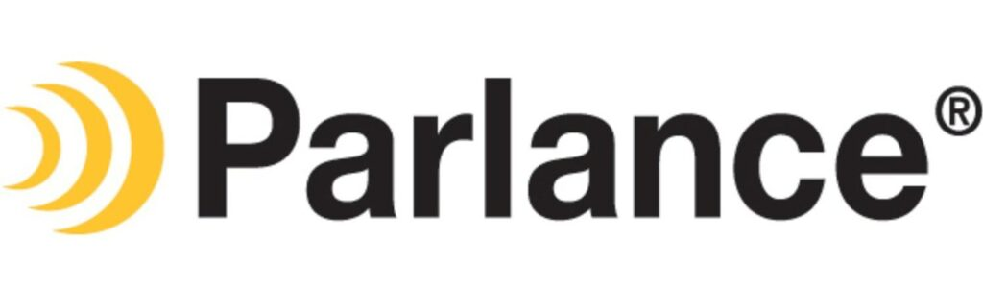
Health Tech


What’s Keeping Healthcare CIOs Up at Night: How to Improve Patient Satisfaction by Handling Calls More Efficiently
Health systems have spent billions on portals while investments in modernizing the voice channel — the dominant preference of healthcare consumers — have taken a backseat.
By Stephanie Baum
“Both conditions at the same time, a randomized digital placebo arm and a therapeutic arm,” he said on the panel. “The therapeutic arm looks very similar to the Lyko study, but the placebo arm has low-dose MDMA as the placebo to address what the FDA [advisory committee] had identified as a functional, unblinding problem, meaning people who were in the placebo arm kind of knew that they were because they didn’t feel the very obvious effects of the drug. So we’re already starting to plug some of the gaps that the FDA identified to make the science better and try to accelerate as much as possible more veterans getting this new line of therapy.”
There are also some efforts by states to move along psychedelic-assisted therapy. For example, the Arizona State Legislature appropriated $5 million for psilocybin (or mushrooms) research dedicated to PTSD among veterans, noted Kyrsten Sinema, U.S. Senator in Arizona.
That said, it’s still important to get FDA approval, she added.
“Only through FDA approval can we ultimately make these medicines widely available around the country in a safe manner, not just for veterans and for folks who are suffering from PTSD, but for individuals who are victims of sexual assault, individuals who’ve had traumatic childhoods,” Sinema argued.
Sponsored Post


The Future of Hospitals and Pharma Companies Will Depend on Strength of Healthcare Analytics Insights
PurpleLab® stands out from others in this sector by providing its data analytics services to several different groups of users across healthcare and pharma companies.
By Stephanie Baum
Sinema also noted that while other treatments for PTSD exist, they aren’t very effective. For example, in exposure therapy (in which people are gradually exposed to situations they fear), people have to relive their trauma over and over. This leads to high dropout rates. With psychedelics, patients are processing their trauma, versus “re-injuring the self and the psyche over and over.”
When asked what Congress is doing in regard to psychedelic-assisted therapy, Congressman Morgan Luttrell responded that this is a “crawl, walk, run scenario.” He noted that he’s taken these medications himself and is a big advocate for them.
“We don’t want to overwhelm the system because even though these medications have been around for centuries, it’s a very new concept, especially to the congressional members who represent their base. … I have to have these conversations with members to not only show them the science and the data that is collected but share my personal experience and why it’s so important that we move forward,” he said. “We’ve put legislation in place and dollars in place for the VA and for the [Department of Defense]. But again, I think if we push too hard, too fast, it will break, and we do not want to do this. We’re talking about lives here.”
If FDA approval of MDMA-assisted therapy for PTSD happens, there is still the question of how the healthcare industry will pay for it, noted Ruth Reader, health and technology reporter at Politico and moderator of the panel. Due to issues with sexual misconduct, it’s possible two therapists might be needed for treatment, which would be expensive.
Sinema responded that there are more trial applications going into the FDA for group settings, which would make treatment cheaper.
“There’s a nonprofit organization in Arizona, Scottsdale Research Institute, that is preparing to do a trial for MDMA in a group setting, also looking at psilocybin in a group setting, that allows you to have two therapists, but also allows you to have multiple people experiencing their own therapeutic experience in a shared setting. … I think there is a world in which this can become available and affordable,” she said. “A big issue, of course, after FDA approval for all the classes of psychedelics is how do we start to gain insurance coverage so that people can get access to this?”
Luttrell also noted that psychedelic-assisted therapy is intended for a “select group of individuals,” not a broader market.

